PDP-11

Phase 2

**Team Number** 3

**Team Members**

Ahmed Mostafa

Seif El Din El Said

Omar Ibrahim

Naiera Magdy

**Bus System Schematic:**

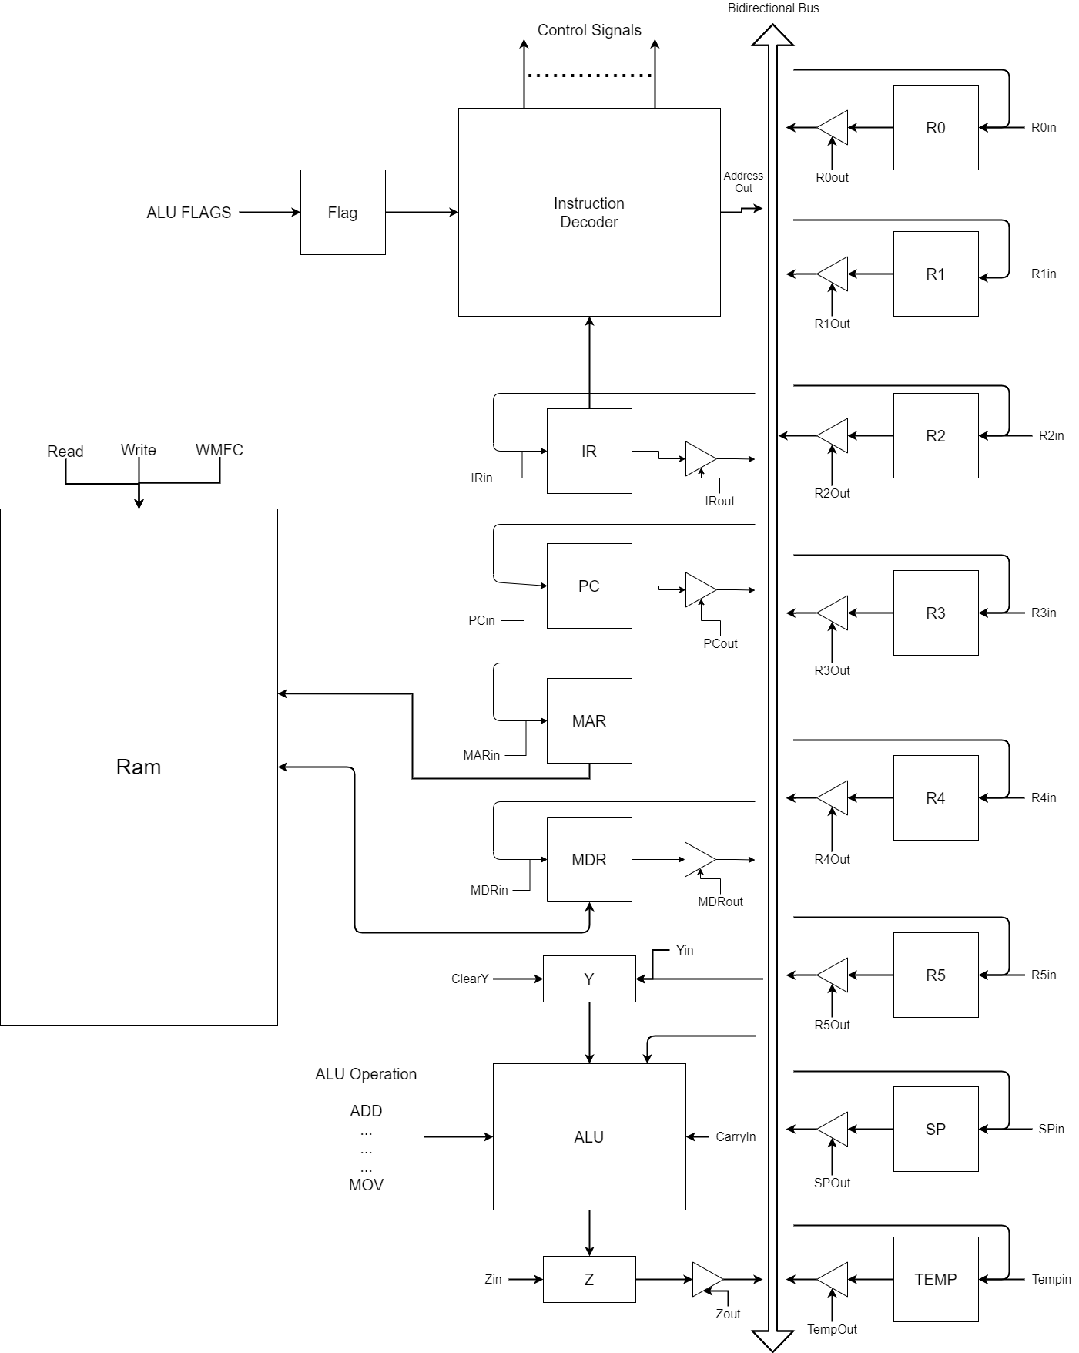

**Micro-Instructions:**

**Some microinstructions are changed and marked with yellow color in the next table.**